**MALAWI UNIVERSITY OF BUSINESS AND APPLIED SCIENCES**

**(MUBAS)**

**FACULTY OF ENGINEERING**

**DEPARTMENT OF ELECTRICAL ENGINEERING**

FINAL YEAR PROJECT REPORT

On

**Machine Learning for Fungal Disease Diagnostics in Crops**

Submitted to

Mr. Mwenecho (Coordinator)

Mr. Alick Vweza (Supervisor)

Submitted By

Brenald Dzonzi (BEEE/14/NE/006)

Mayamiko Msonkho (BECE/14/PE/014)

**11th October 2021**

# Acknowledgements

First and foremost, we'd like to thank God for providing us with the strength and guidance we needed to complete this project. We would not have had the wisdom or the physical ability to do so without him.

We would like to thank our project supervisor, Mr. Arick Vweza, for his kind assistance, motivation, and inspiration throughout this project. His advice and assistance kept us on track. Finally, we'd like to express our deepest gratitude to everyone who helped us with this project.

# Abstract

The process of detecting plant disease is very important to the farmers and the agricultural sector as a whole. Normally, when the farmers detect a disease that they don’t know they have to wait for the plant pathologist to tell them what the disease is, and this could take a lot of time. We are providing a way of detecting plant diseases instantly without waiting for the plant pathologists to check out the crops. We used machine learning (ML) tools like MobileNet in order to train a ML model to detect the type of crop disease that has attacked the crops. We Achieved a test data accuracy of ≈ 97% and a validation accuracy of ≈ 96%. While the project was successful in designing a machine leaning model that was able to differentiate what fungal disease the maize crop has, there are still considerable drawbacks and limitations with the model that could improve the model to better generalize and hopefully work in the real world.

Table of Contents

Acknowledgements ii

Abstract iii

List of Tables 3

List of Figures 4

1.0. Introduction 5

2.0. Literature Review 6

3.0. Detailed Design 8

3.1. Mobile Design 9

3.1.1. Login Page 9

3.1.2. Home Page 10

3.1.3. Application Camera View 11

3.1.4. Results View 12

3.2. Application Programming Interface (API) 13

3.3. Machine Learning Model and service Design 16

3.3.1 Dataset Used 20

3.3.2 Training 21

4.0. Presentation of Data 22

5.0. Discussion of Findings. 28

5.1. Challenges 29

6.0. Conclusions and Recommendations 30

References 32

Appendix 1: Detailed CNN Model 35

Appendix 2: Machine Learning Service Code 44

Appendix 3: The Imgsave Controller Code (API) 46

Appendix 4: Imgsave model code (API) 50

Appendix 5: Agriadmin Code (API)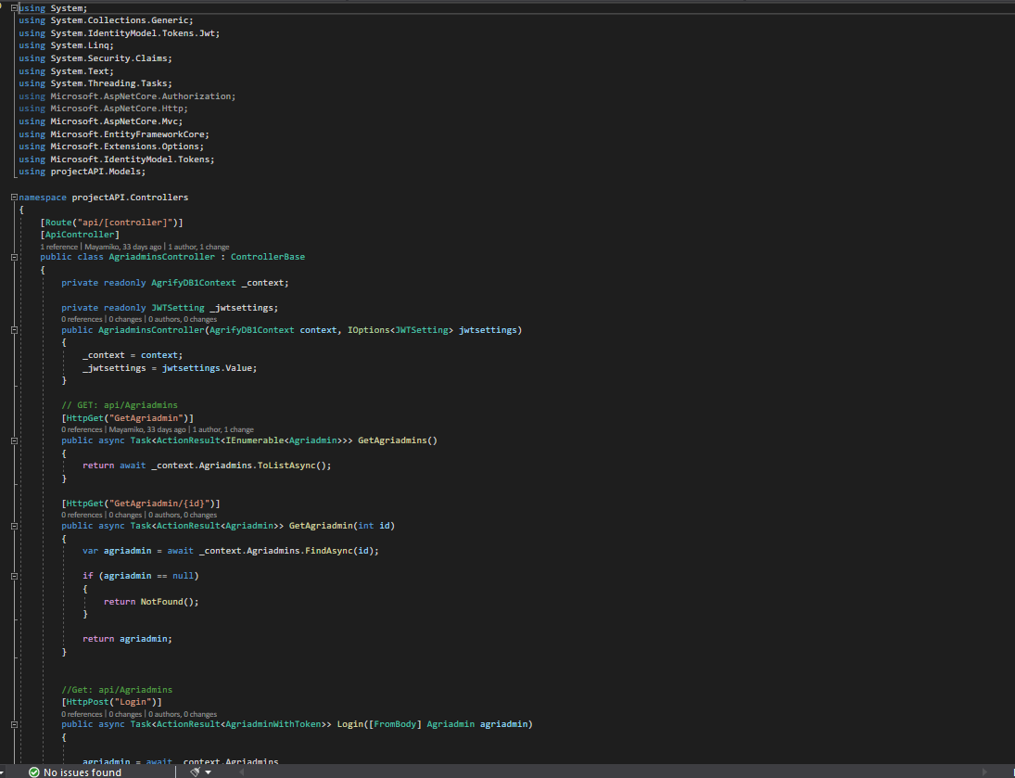 51

Appendix 6: Agriadmin Model (API) 54

# List of Tables

Table 1: Architecture of the MobileNet 20

Table 2: Training Values 24

# List of Figures

Figure 1 Architecture of MACN from (Sun, et al., 2020) 8

Figure 2: Mobile design (Avila-George, et al.,2018) 9

Figure 3: High Level System Design 10

Figure 4: Detailed High-Level System Design 11

Figure 5: Login Screen 12

Figure 6: Home Screen 13

Figure 7: Application Camera Screen 14

Figure 8: Results View Screen 15

Figure 9: Database Table 16

Figure 10: Agriadmin API Routes 17

Figure 11:API Imgsaves Routes 18

Figure 12: Convolution Unit 20

Figure 13: Depth-wise Separable Convolution Unit 21

Figure 14 Standard Convolution and Depthwise separable convolution (Chollet, 2017) 22

Figure 15: Sample of Training Dataset 23

Figure 16: Initial Evaluated Results 24

Figure 17 Accuracy of Validation and Training Set Against Epoch 25

Figure 18: Loss error of Validation and Training Set Against Epoch 26

Figure 19:Classification of Image 27

Figure 20:Classification of healthy Image 27

Figure 21: Results View Screen 28

Figure 22 Gray Leaf Spot Image 28

Figure 23 Input Layer of Network 29

Figure 24 Features in Convolution Layer Number 1 29

Figure 25 Feature Map in Depthwise Convolution Layer Number 2 29

Figure 26 Feature Map in Convolution Layer Number 3 29

# Introduction

The Evolution of Computers has changed our lifestyle and how we tackle different types of problems. Computers have made impact in most of our aspects of life through their tremendous technological development in terms of processing power, flexibility and accessibility (Pujari, et al., 2015). Through this improvement, computers are now being used in image processing which is the technology that helps to recognize patterns in images and categorises the different types of images that are processed. This project will be tackling a problem of detecting fungal diseases in crops but we will focus mainly on *Maize and Tobacco* which are the main crops grown in Malawi (Anon., 2018). The project will aim at classifying the type of fungal disease and hopefully be a building block to build a system that can provide recommendations on how to deal with the disease. The current problem that farmers face is that the aforementioned diseases can manifest in the plants but cannot take immediate action, as they need to wait for specialists to perform a diagnosis. From the assessment of the specialists, they can provide advise on how on how to deal with it.

One of the systems that is currently being used is the *plant clinics.* These *plant clinics* are where farmers get recommendations from plant pathologists and plant health experts (specialist). This is an initiative by CABI’s Plantwise, which is a global program by CABI that helps farmers to lose less of what they grow by dealing with things that reduce harvest, one of these things are the diseases that attack plants. As of now the Plantwise project uses a WhatsApp group for plant pathologists and plant health experts, the group is called “*Malawi Plant Doctors*”, where they ask each other questions as a kind of peer counselling. These plant pathologists then respond to the farmers who have asked them the questions **Invalid source specified.**. The problem with this system is that it’s hard to track information on WhatsApp because messages pile up and they are not categorized. and farmers have to wait for the plant pathologists to consult before receiving feedback.

Our project will provide a way of giving immediate results on the disease that has attacked the plants and also give the recommended solution and every step that needs to be taken in order to apply the solution. We propose the use machine learning techniques such as image processing in order to detect and categorise the diseases. Thereafter, the application should be able to provide ways on dealing with the disease including the steps that the farmer will have to follow to get the disease under control. This application will be installed on the farmers’ android device. The plant pathologists and plant health experts will also have access to this application, they are the ones who will help to improve the machine learning solution by adding new diseases to the catalogue.

# Literature Review

In this literature review, we will describe three systems that were developed in order to tackle a similar problem. The only difference with the proposed system is that we will work on not just one crop but two crops namely: Maize and Tobacco. Which means it will be more versatile than the ones mentioned in this literature review. The projects we are going to look at are as follows: *Tobacco-disease Image Recognition via Multiple-Attention**Classification Network* from(Sun, et al., 2020)*, An Application of image processing techniques for Detection of Diseases on Brinjal Leaves Using K-Means Clustering Method* from (Anand, et al., 2016)*, Using Artificial Neural Networks for detecting damage on Tobacco Leaves caused by Blue mould* from (Avila-George, et al., 2018)

***Tobacco-disease Image Recognition via Multiple-Attention Classification Network***

This system was developed by students from three Universities namely, Benihana University, the School of Software, Yunnan academy of Tobacco Science, and Beihang university Yunnan Innovation Institute in China. This proposed study used Multiple-Attention Classification Network (MACN) in order to improve the existing image classification from two aspects, namely: the acquisition of low-level features based on transfer-learning and the extraction of small-scale dataset. MACN was used due to limited samples of tobacco-disease images. This way of detecting diseases is very complicated and may require more processing power which may be a bit expensive and it does not provide a user interface that a user can interact with the system intuitively.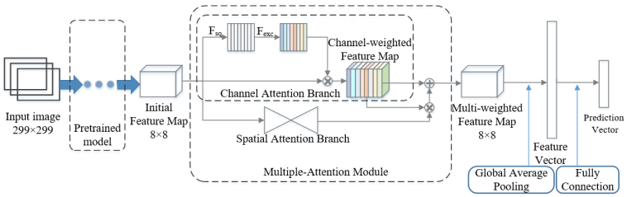

Figure 1 Architecture of MACN from (Sun, et al., 2020)

***An application of image processing techniques for Detection of Diseases on Brinjal Leaves Using K-Means Clustering Method***

This was developed by students from Amrita School of Engineering at Amrita University in India. The methodology for detecting the leaf disease in brinjal (eggplant) plant Used K-means Clustering algorithm for segmentation and Neural-network for classification. The feature extraction was done by using colour co-occurrence method, which is the method of extracting both the texture and colour of an image to arrive at unique features which represent that image. We borrow the idea of having a GUI (Graphical User Interface) on a computer for adding the solutions and new diseases to the categories and it will be more user friendly than the one they have now.

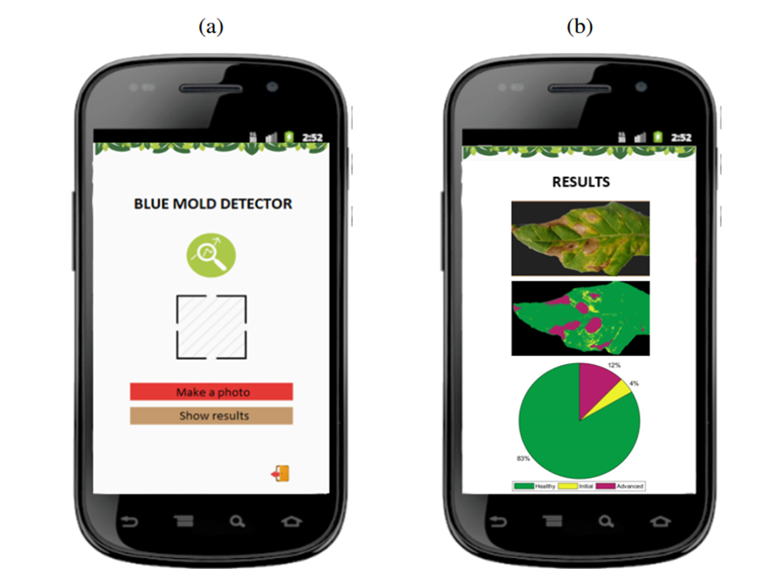

Figure 2: Mobile design (Avila-George, et al.,2018)

***Using Artificial Neural Networks for detecting damage on Tobacco Leaves caused by Blue mould* from**

This project was done by students from University of Guadalajara and Ensenada Centre for Scientific Research and Higher Education. Their project yielded a software that was used to detect damage in tobacco leaves by the fungus blue-mould. They used Artificial neural networks to recognise patterns from images that was inputted in the software. They used 40 images in order to train the algorithm and test it. After some experiments the model produced accuracy that was higher than 97% which means that it was as close to the visual analysis of human experts in tobacco crop. They also developed a mobile app that was going to be used by farmers. The limitation with this project was that it only worked with one crop like the other two projects mentioned above. And it’s not known whether the software will perform well after including more than two different crops with that should detect different diseases.

# Detailed Design

This is essentially how the project will function. The machine learning model is accessed through an API from the mobile application as illustrated from the following diagram

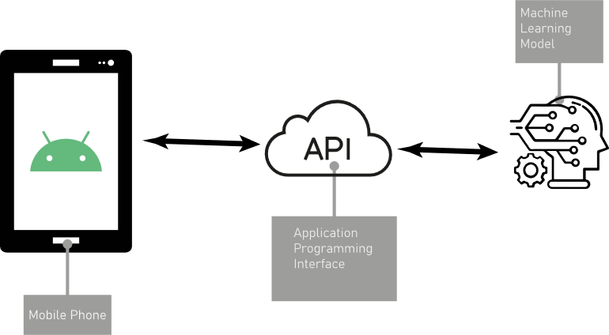

Figure 3: High Level System Design

Firstly, the farmer or researcher will capture the data from a mobile device that is running an android application that allows capturing images using the camera. The data captured will be transmitted to the machine learning model through the API that is on the server. The model will perform the necessary processing, which will entail image annotations and further analytics for researchers. The result will be coupled with the classification result. Furthermore, the results will be transmitted to the farmer or researcher who made the initial request through the internet through by the API to the mobile phone. The detailed process of how the system functions from image acquisition to classification is show in Figure 4

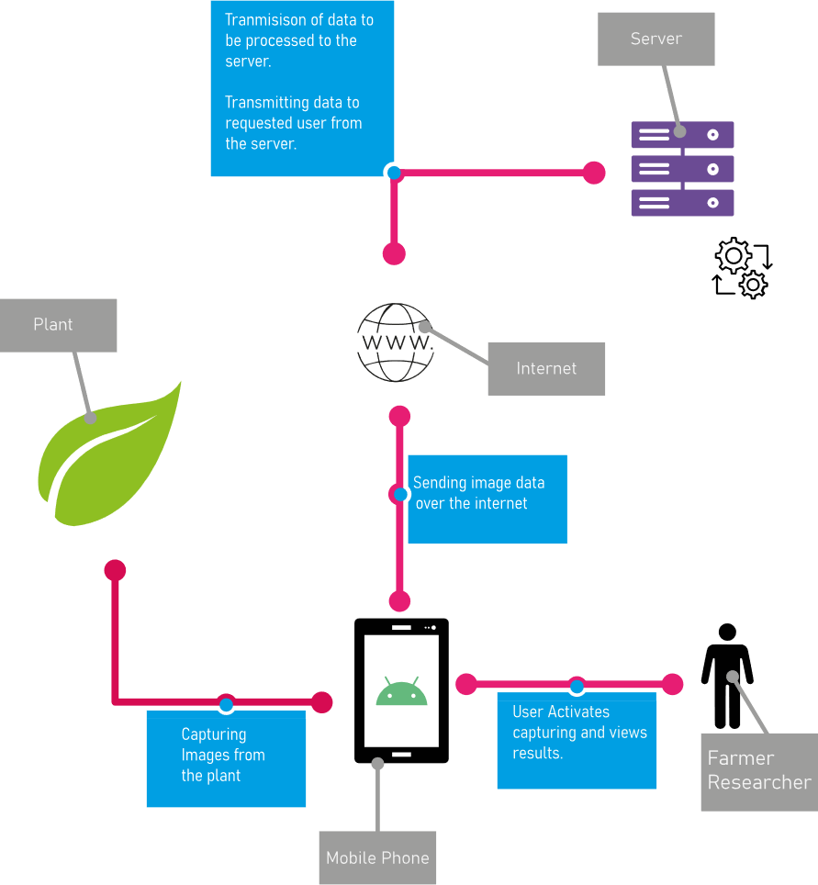

Figure 4: Detailed High-Level System Design

Each part of the system will be described in detailed starting from the Android mobile application then followed by the ASP.net API and finally the machine learning model written in python.

## Mobile Design

## Login Page

This is the first page or screen the farmer will interact with; on this page the farmer has to enter the credentials that they have been given. These credentials will allow the farmer to log into the system which will allow the system to retrieve the farmers data.

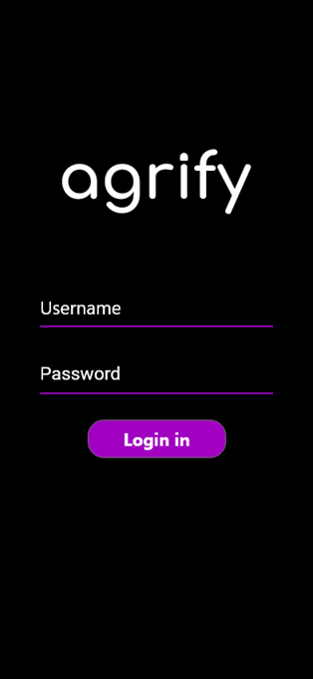

Figure 5: Login Screen

## Home Page

This the screen or page where the farmer will be shown previous captures of the crops. This screen will let the farmer know if they the crop image has been uploaded to the server for further processes. Furthermore, it also allows the farmer to navigate to the detailed view of the processed images. It also contains the users profile button that allows the user to navigate the about page, which contains details of the user.

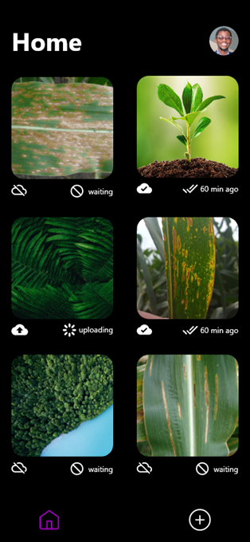

Figure 6: Home Screen

## Application Camera View

This view allows the farmer to capture the image of the crop. The farmer will be able to allow the application to upload the image or delete the image and take another photo depending on how they deem the quality of the image to be.

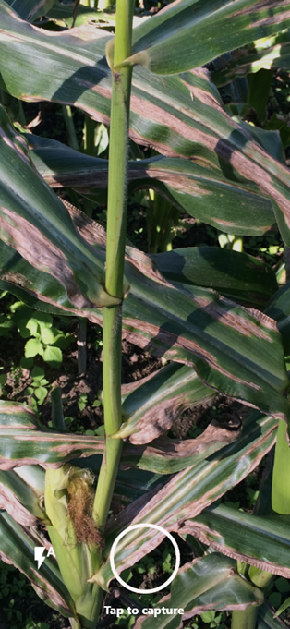

Figure 7: Application Camera Screen

## Results View

This is the screen or page where the farmer is able to view the image that has been uploaded to the server and the status of the process. Furthermore, the farmer is able to gain some feedback in terms of what class of category is the image in, this is a classification operation that the machine learning model has performed. The classification also has some level of confidence that is processed and viewed on this screen.

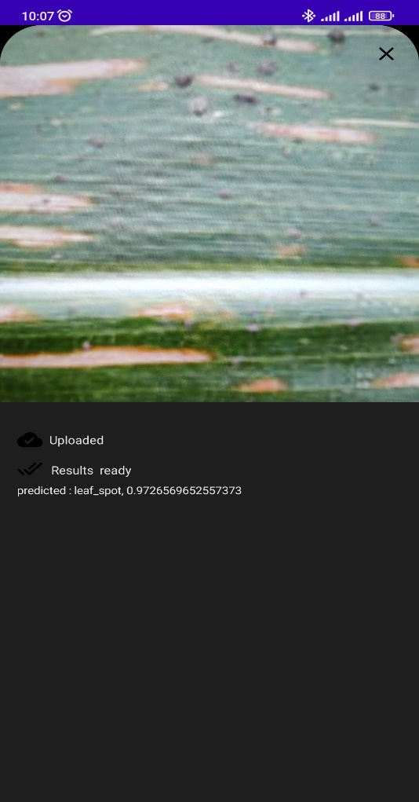

Figure 8: Results View Screen

## Application Programming Interface (API)

The API is the interface between the android application and the machine learning model. It receives the unprocessed images from the android application and stores the image in a folder on the server. It processes the information and stores the data in the database, the data includes a download link, the image record id, the id of the person who uploaded the image and some default values for the disease detected (it is updated with the machine learning model).

The machine learning model service polls the API for unprocessed images. This data is delivered to the machine learning model through the JSON file format, then model processes the image and sends a request back to the API that has all the information that the model has predicted. This information updates the database of the API and thereby updating the results view screen on the android application.

The prototype we have designed uses two tables, namely the Agriadmins table – which is the table that contains all the user information that has data which is summarized in Figure 9 and the Imgsave table – this is the table that consists of all the image information that the users have uploaded and ins mostly used for storing and processing the images. The API uses JSON Web Token (JWT) as a protection scheme for all the information that passes through the API. JWT is an open standard (Jones, et al., 2015) that specifies a compact and self-contained method for securely sending information as a JSON object between parties. Because it is digitally signed, this information can be checked and trusted. JWTs can be signed with either a secret (using the HMAC[1] technique) or a public/private key pair (using RSA[2] or ECDSA[3]). An authorization token is generated when a user logs into the system.

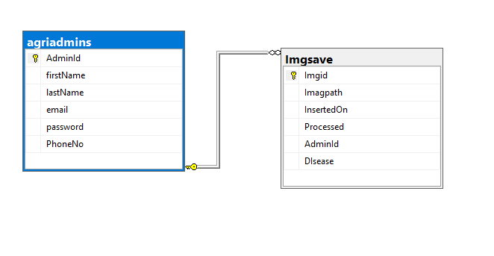

Figure 9: Database Table

The OpenAPI specification is used in the implementation and the designing of the API with the use of Swagger (Anon., n.d.).

The *Agriadmins* route uses has a few operations that modify the database. The GET operation is performed on two routes; one which gets the Agriadmins records and exposes them through a JSON object and another which uses the assigned ID and the other which gets all the available Agriadmins. It also has two POST routes; one which performs the login operation and the other is for creating a new user, which is synonymous to the singing up operation. The PUT operation on this route updates the Agriadmin’s record in the database through the supplied user ID. Lastly, the route has a DELETE operation which, will remove or delete the Agriadmin’s record in the database.

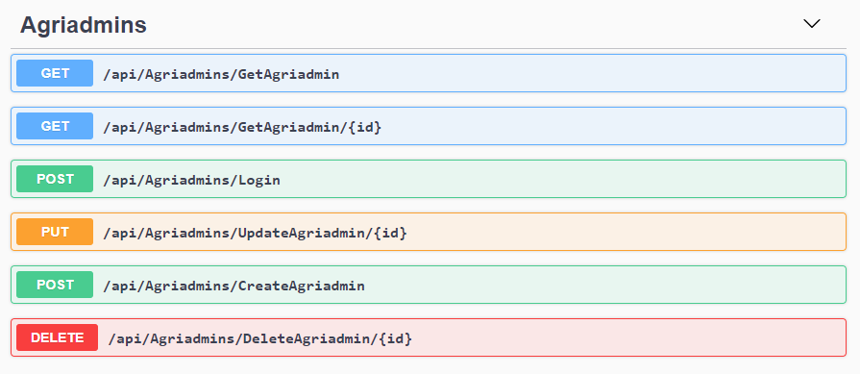

Figure 10: Agriadmin API Routes

The Imgsaves route where the CRUD operations of the images are performed. This table has five GET operations on the route. The first GET route gets the image by ID, the second GET operation is *GetUnprocessedImage*, which works with the Machine Learning model to get the unprocessed image for disease prediction. The third GET is the *GetImgSavesByAdmin* which retrieves the images that have been saved in the database by a particular Agriadmin user. The fourth GET is the one that the admin uses if they want to see how many images have been saved in the system whether processed or unprocessed. The last GET is *getImagefile* which is the one that downloads the image file from the folder in the server by its file name. The route also has two PUT opretaions, one which updates the table with processed image from the machine learning model and the other PUT operation allows the Agriadmin to manually update the table using the ID of the image. The route also has two POST operations; one which saves the path of the image file and the other which saves the image file name. Lastly the route has a DELETE operation which provides the authorized admin to delete any saved image by the image ID.

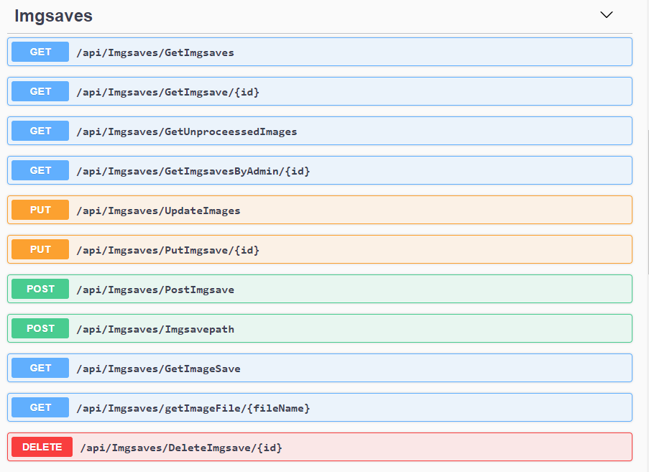

Figure 11:API Imgsaves Routes

## Machine Learning Model and service Design

The machine learning model that was designed and implemented used the blueprint of the Mobilenets architecture. MobileNets are composed of depth-separable convolution layers. Each depth-wise separable convolution layer is made up of a depth-wise and a pointwise convolution. A MobileNet network contains 28 layers if depth-wise and pointwise convolutions are counted separately. A typical MobileNet contains about 4.2 million parameters, which can be lowered further by correctly adjusting the width multiplier hyperparameter. The introduction of the separable convolution layers instead of the normal convolution layers allows the model to perform much better in the real world and on edge devices, which consist of devices such as mobile phones, embedded devices and devices with low processing power.

The general architecture of the MobileNet architectures is as follows,

| **TYPE** | **STRIDE** | **KERNEL SHAPE** | **INPUT SIZE** |
| --- | --- | --- | --- |
| Conv | 2 | 3 × 3 × 3 × 32 | 224 × 224 × 3 |
| Conv dw | 1 | 3 × 3 × 32 | 112 × 112 × 32 |
| Conv | 1 | 1 × 1 × 32 × 64 | 112 × 112 × 32 |
| Conv dw | 2 | 3 × 3 × 64 | 112 × 112 × 64 |
| Conv | 1 | 1 × 1 × 64 × 128 | 56 × 56 × 64 |
| Conv dw | 1 | 3 × 3 × 128 | 56 × 56 × 128 |
| Conv | 1 | 1 × 1 × 128 × 128 | 56 × 56 × 128 |
| Conv dw | 2 | 3 × 3 × 128 | 56 × 56 × 128 |
| Conv | 1 | 1 × 1 × 128 × 256 | 56 × 56 × 128 |
| Conv dw | 1 | 3 × 3 × 256 | 28 × 28 × 256 |
| Conv | 1 | 1 × 1 × 256 × 256 | 28 × 28 × 256 |
| Conv dw | 2 | 3 × 3 × 256 | 28 × 28 × 256 |
| Conv | 1 | 1 × 1 × 256 × 512 | 14 × 14 × 256 |
| Conv dw | 1 | 3 × 3 × 512 | 14 × 14 × 512 |
| Conv | 1 | 1 × 1 × 512 × 512 | 14 × 14 × 512 |
| Conv dw | 1 | 3 × 3 × 512 | 14 × 14 × 512 |
| Conv | 1 | 1 × 1 × 512 × 512 | 14 × 14 × 512 |
| Conv dw | 1 | 3 × 3 × 512 | 14 × 14 × 512 |
| Conv | 1 | 1 × 1 × 512 × 512 | 14 × 14 × 512 |
| Conv dw | 1 | 3 × 3 × 512 | 14 × 14 × 512 |
| Conv | 1 | 1 × 1 × 512 × 512 | 14 × 14 × 512 |
| Conv dw | 1 | 3 × 3 × 512 | 14 × 14 × 512 |
| Conv | 1 | 1 × 1 × 512 × 512 | 14 × 14 × 512 |
| Conv dw | 2 | 3 × 3 × 512 | 14 × 14 × 512 |
| Conv | 1 | 1 × 1 × 512 × 1024 | 7 × 7 × 512 |
| Conv dw | 2 | 3 × 3 × 1024 | 7 × 7 × 1024 |
| Conv | 1 | 1 × 1 × 1024 × 1024 | 7 × 7 × 1024 |
| Avg Pool | 1 | Pool 7 × 7 | 7 × 7 × 1024 |
| Fully Connected | 1 | 1024 × 1000 | 1 × 1 × 1024 |
| Softmax | 1 | Classifier | 1 × 1 × 1000 |

Table 1: Architecture of the MobileNet

The standard convolution unit that is denoted as Conv in the table above is as follows,

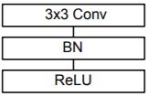

Figure 12: Convolution Unit

The unit consists convolution kernel with a 3x3 size and moves across the receptive field of the image to see if some specific feature or features is present. These features could be edges, colours, or higher dimensional features. The block is followed by a batch normalization (BN) operation. It is an algorithmic method for making Deep Neural Network (DNN) training faster and more stable. It consists of adjusting activation vectors from hidden layers using the current batch’s first and second statistical moments (mean and variance) (Tan & Le, 2020).

The last step used the ReLU activation function. The rectifier or ReLU (Rectified Linear Unit) activation function is an activation function defined as the positive component of its argument. Which is mathematically illustrated as follows,

$$f\left(x\right)=x^{+}=max⁡(0,x)$$

A single Depthwise separable convolution unit or layer has the following layout, which is denoted as Conv dw,

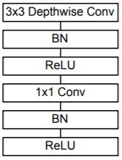

Figure 13: Depth-wise Separable Convolution Unit

While standard convolution computes channel-wise and spatial-wise computation in a single phase, depthwise separable convolution divides the calculation into two steps: Depthwise convolution employs a single convolutional filter for each input channel, while pointwise convolution is used to generate a linear combination of the depthwise convolution output (Chollet, 2017). Pointwise convolution is a convolution kernel with a size of 1x1 that projects the depthwise convolution's output channels onto a new channel space. This is visually illustrated in Figure 14.

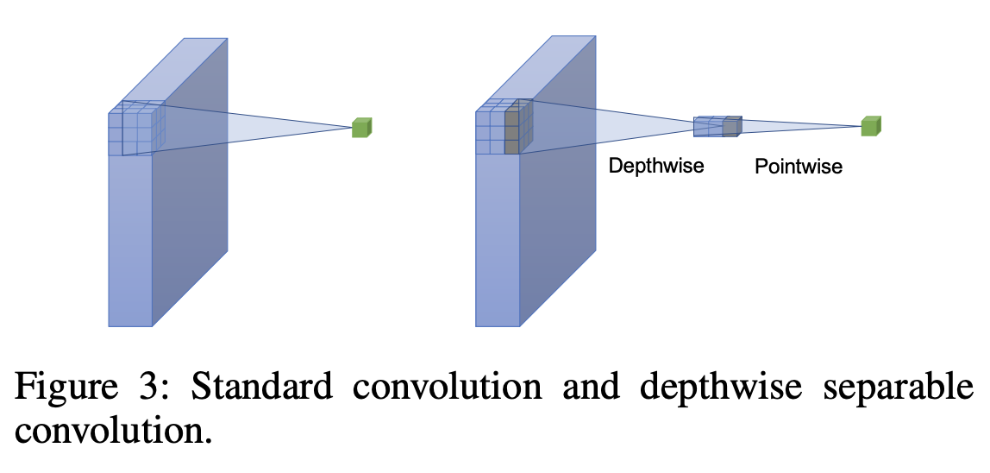

Figure 14 Standard Convolution and Depthwise separable convolution (Chollet, 2017)

### 3.3.1 Dataset Used

The PlantVillage dataset has over 50,000 expertly curated images on healthy and infected leaves of crops plants. These data are a crowdsourced effort that aims at enabling computer vision approaches to help solve the problem of yield losses in crop plants due to infectious diseases.

For this project we used 3852 images that were part of the four of the classes of the maize crop. The classes that were used to train the model are, blight infected, common rust infected, grey leaf spot infected and healthy crops.

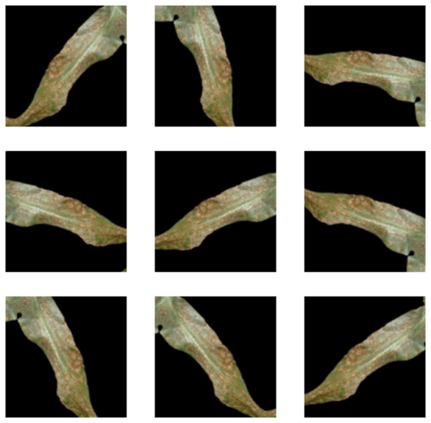

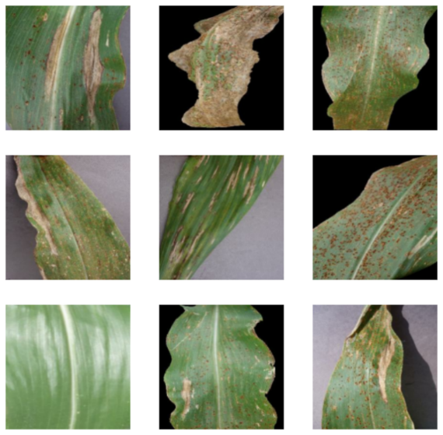

Figure 15: Sample of Training Dataset

### 3.3.2 Training

The training process for the neural network was done using a batched technique. The dataset was split into two sets, a training set and a test set. The training set consisted of 92 batches which consisted of 32 images. The test set consisted of 20 batches of similar size and was used for validation of the CNN during training. The 5 remaining batches were used for validation after training the CNN. The optimizer used for training was the Adam optimizer, which is an extension to stochastic gradient descent. It was chosen because it is efficient on large amounts of data, especially on image dataset. The loss function that was used is the categorical cross entropy, is a commonly used loss function in multi-class classification tasks.

# Presentation of Data

The machine leaning model that was proposed in this project went through the process of training. This is the process of fitting the collected data to the model that was proposed – modified MobileNet, specifically modified MobileNetV1 model. The model was initially evaluated with the collected data and the following were the results obtained

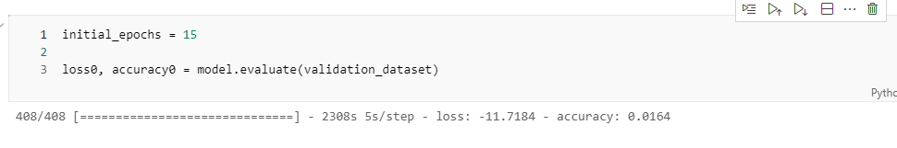

Figure 16: Initial Evaluated Results

The above image illustrates the process of evaluation and the error loss value that was obtained, which was about -11.7 with a lot accuracy of 1 percent.

The model was then trained over 15 epochs or 15 iterations. The results that were obtained during the training process over the aforementioned times are shown in the Table 2. The first column shows the epoch or iteration, followed by how long in seconds, it took to train the model. The next column is the accuracy of the test data and next to it is the results of the validation dataset.

|  |  |  |  |
| --- | --- | --- | --- |
| Epoch | Time (seconds) | Test data | Validation data |
| 1 | 622 | 90.14 | 94.10 |
| 2 | 623 | 94.32 | 95.25 |
| 3 | 659 | 95.65 | 96.89 |
| 4 | 629 | 96.56 | 96.89 |
| 5 | 614 | 96.50 | 97.21 |
| 6 | 632 | 97.21 | 96.39 |
| 7 | 614 | 96.82 | 97.54 |
| 8 | 607 | 96.95 | 97.54 |
| 9 | 612 | 96.95 | 96.75 |
| 10 | 607 | 97.70 | 96.89 |
| 11 | 583 | 97.11 | 96.23 |
| 12 | 578 | 96.72 | 97.21 |
| 13 | 584 | 96.98 | 96.72 |
| 14 | 575 | 97.14 | 96.72 |
| 15 | 593 | 97.44 | 96.23 |

Table 2: Training Values

The data in Table 2 was placed on a graph for intuitive interpretation. The graph shows a plot of accuracy against epoch. The graph shows two curves, namely the training dataset and the validation dataset.

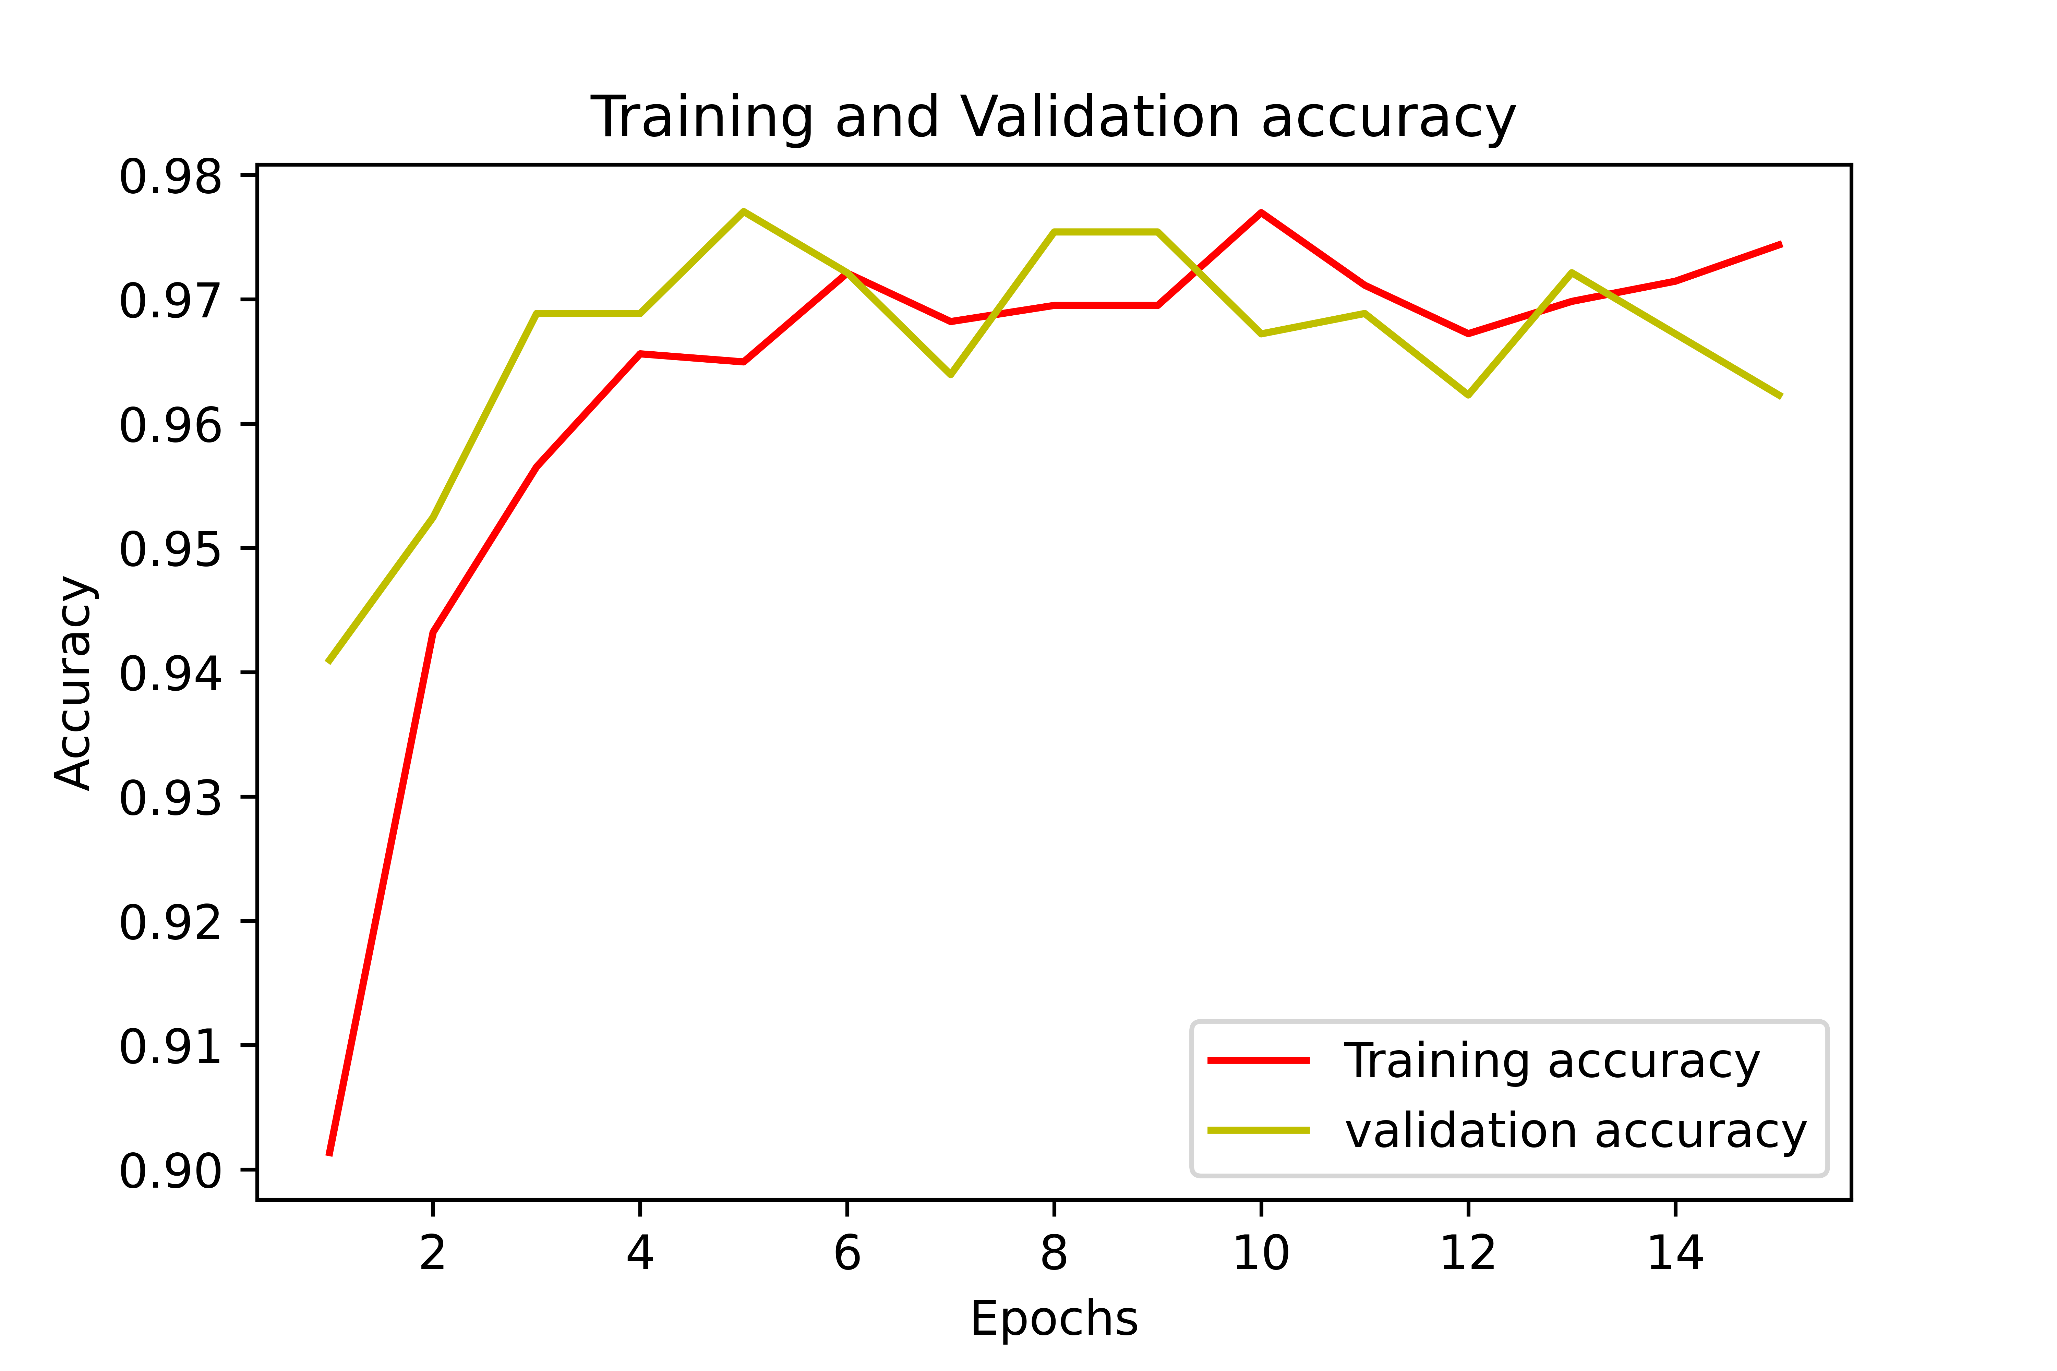

Figure 17 Accuracy of Validation and Training Set Against Epoch

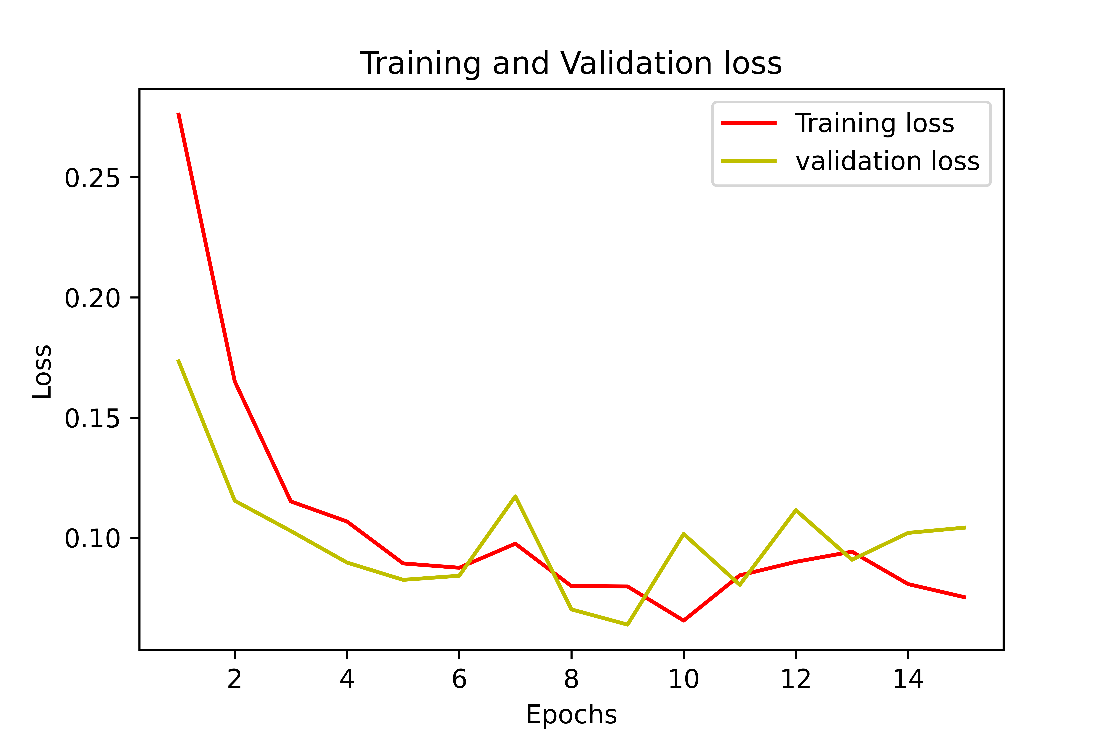

Figure 18: Loss error of Validation and Training Set Against Epoch

Figure 17 shows the loss error that the model generated during the training process. The graph shows the plot of the loss error against epoch. This graph shows the training and validation error curves.

After the model was trained and evaluated what followed was testing the performance of the model on images. Figure 18 shows the model classifying an image in the validation dataset and the accuracy was observed to be over 95 percent on the common rust category. Figure 19 shows an accuracy of 99 percent on a healthy image.

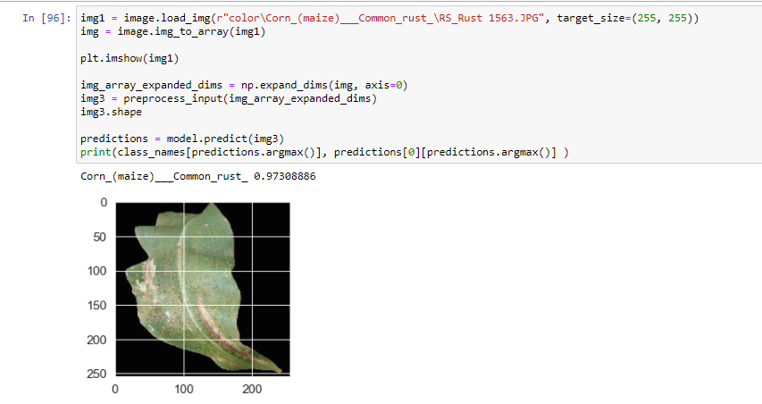

Figure 19:Classification of Image

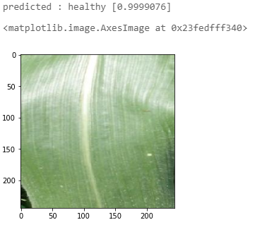

Figure 20:Classification of healthy Image

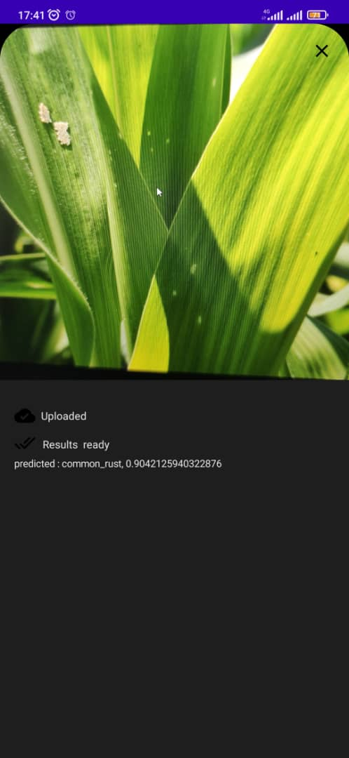

Figure 21: Results View Screen

The model’s performance was tested with an image that was taken on the internet. The image had some artifacts and the predicted category was common rust though it is clearly seen as a healthy plant.

The feature map of the neural network was also observed and the following images show the input feature map, which is simply 3 channel input and convolution feature maps obtained during the training process but observed by passing Figure 22 through the network.

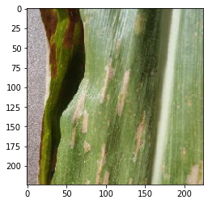

Figure 22 Gray Leaf Spot Image

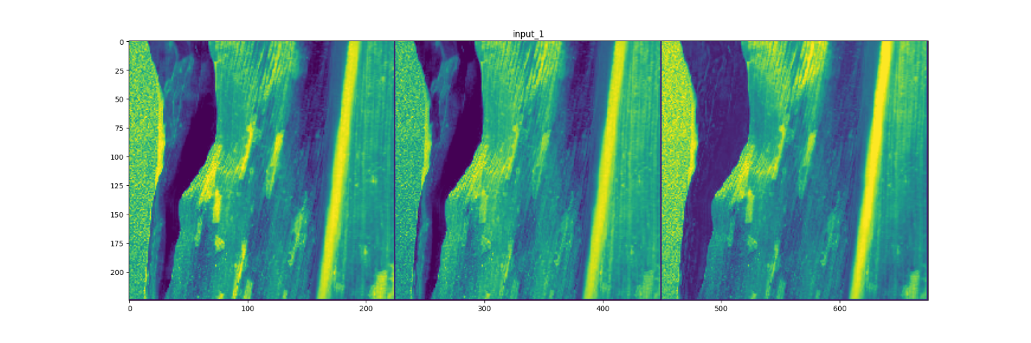

Figure 23 Input Layer of Network



Figure 24 Features in Convolution Layer Number 1



Figure 25 Feature Map in Depthwise Convolution Layer Number 2



Figure 26 Feature Map in Convolution Layer Number 3

# Discussion of Findings.

The model was able to achieve an approximate 97 percent accuracy on the training data set and it was also able to achieve an approximate accuracy of 96 percent on the validation dataset. It was observed that the initial model had a low score when it was evaluated, this is due to the raw Imagenet weights which were provided by the framework Tensorflow and Keras. It should be noted that this result was anticipated. The accuracy of the model increased during the training process on each epoch until it plateaued or reached a steady state around the 10th epoch.

The initial training of the model suffered from local minima. A local-optima is the extrema (minimum or maximum) of the objective function for a given region of the input space, e.g. a basin in a minimization problem. An objective function may have many local-optima, or it may have a single local-optima, in which case the local optima is also the global-optima. A local optimization algorithm, also called a local search algorithm, is an algorithm intended to locate a local-optima. It is suited to traversing a given region of the search space and getting close to (or finding exactly) the extrema of the function in that region.

The model had difficulty achieving a global optimization or minima. A global-optima is the objective function's extrema (lowest or maximum) for the whole input search space. An objective function may have one or more global-optima; if there are more than one, the problem is known as a multimodal optimization problem, and each optima has a distinct input but the same objective function evaluation. When a function locates the optima for an objective function that may contain local-optima, this is referred to as global optimization. An objective function always has a global-optima, but it may also have local optima with worse objective function evaluations to the global-optima.

A global optimization algorithm, also known as a global search algorithm, seeks a global-optima. It is well suited to exploring the full input search space and coming near to (or finding exactly) the function's extrema.

The model in this case suffered from local-minima. This is as a result of the small parameter’s that the model was trained on initially. The number of parameters that were trained were approximately 10 thousand and 4 million paraments were left frozen or unchanged during the training process the model’s parameters were constrained to the default weights which were from the transfer learning model.

When the model was unfrozen and left to train, and all the parameters were updated during this process, the model converged to a solution that was optimal. This was observed by the accuracy measured increasing to the reported accuracy of 97 percent.

Furthermore, the model experienced problems with images that had artifacts that were not in the training set. Figure 27 shows the sample of the data that was used for the training, these are images with the size of 256x256. The images show that the training set did not have any artifacts to help the model generalize properly. The initial layers of the model are able to use the color of the image as a feature, and this is later used in the network for classification. Therefore, it is observed that the dataset of common rust has a lot of brown. The machine learning model would use this feature to classify any image with a lot of brown as common rust. That could be why the image in Figure 28 that contains a brown artifact would be predicted as common rust by the model instead of a healthy plant.

The feature maps shown in the last chapter illustrate how each convolution layer ultimately contributes to the outcome of the prediction. Figure 22 is passed through the neural network and the features are then plotted to give insight on how each neuron in the first layers contributes to prediction or classification. The convolution layers that are show to be empty signify that the feature that the neuron was supposed to look for did not appear, and if the neuron detected a feature that is of interest, then it will fire, this is observed on the images that some data appears in the feature map.

The machine learning model that was trained with the dataset collected attained a high accuracy but did not properly classify images that had artifacts. It should be noted that the project achieved what was proposed but it will require additional work to properly make project work in real life.

## Challenges

*Neural network compatibility.* The model training process brought about different challenges as each model that was tested had different means to which the model accepted inputs. The Imagenet models had a fixed input as to how they are to receive the input image most of them amounting to about an image size of 256 x 256 x 3, but in our case the model that we used Mobilenet Version 1 for our transfer learning model was 244 x 244 x 3. This made switching for one model to another difficult.

*Framework compatibility.* The frameworks that we used: Keras with a Tensoflow backend. The frameworks are constantly being updated and this meant that each version of the frameworks was not backward compatible to some extent, and we had to spend hours trying to understand how to use the framework instead of focusing on work on issues on the model.

*Dataset size.* The dataset used was small and that is why we decided to use transfer learning, as this would have given better results compared to coming up with a custom model for this problem. The problem was a computer vision problem and this is inherently a domain that performs better with more data.

*Computational power.* Machine learning techniques that are images based and that have a deep network are computationally expensive because of the mathematically operations that occur in the model. {gradient decent and updating equations here}

Each layer has parameters that would need to be updated. In our case we had 1,054,724 parameter that needed to be updated.

# Conclusions and Recommendations

The goal of the project was to design and implement a machine leaning based fungal disease diagnostic system for the maize crop. The design and the implementation process have been completed accordingly having a final result of a system with the functionality that met he design requirement.

While the project was successful in designing a machine leaning model that was able to differentiate what fungal disease the maize crop has, there are still considerable drawbacks and limitations with the model that could improve the model to better generalize and hopefully work in the real world.

The recommendations are as follow, firstly, there is need to collect data with different lighting conditions as it was noted that the model did not work perfectly with images with different lighting conditions. Having a dataset that has different lighting conditions would help in getting better overall performance with real world situations.

Secondly, the model was studied with single set of hyperparameters. Different sets of hyperparameters would have probably given a different result and would aid in developing a model that is more robust, there is need to study the model with different parameter to gain insight on the performance of the model the network performance with a variation of hyper parameters.

The development of the model was used with transfer learning due to the limited dataset that was obtained. The design and development of a custom convolution neural network for this specific problem is a study that would give promising results.

Lastly, the system developed was not tested with real world data, but most of the images used were images that were available on public domain. Studying how the model would perform in the real world could aid in the improving the performance on real world.

# References

Anand, R., Veni, S. & Aravinth, J., 2016. An Application of Image Processing Techniques for Detection of Diseases on Brinjal Leaves Using K-Means Clustering Method. *2016 International Conference on Recent Trends in Information Technology (ICRTIT).*

Anon., 2018. *Impact of Plant Clinics on Disease and Pest Management, Tomato Productivity and Profitability In Malawi,* s.l.: s.n.

Anon., 2021. RSA (Cryptosystem). *Wikipedia,* 10.

Anon., n.d. *(PDF) Introduction to Artificial Neural Networks.* s.l.:s.n.

Anon., n.d. *Artificial Neural Network | Brilliant Math & Science Wiki.* s.l.:s.n.

Anon., n.d. *Delivering Messages from Plant Clinics: The Influence of Communication on Farmer's Perception and Uptake of Advice.* s.l.:s.n.

Anon., n.d. *HMAC (Hash-Based Message Authentication Codes) Definition | Okta.* s.l.:s.n.

Anon., n.d. *Impact of Plant Clinics on Disease and Pest Management, Tomato Productivity and Profitability In Malawi.* s.l.:s.n.

Anon., n.d. *OpenAPI Specification - Version 3.0.3 | Swagger.* s.l.:s.n.

Anon., n.d. *Structural Health Monitoring of Civil Infrastructure Systems | ScienceDirect.* s.l.:s.n.

Avila-George, H. et al., 2018. Using Artificial Neural Networks for Detecting Damage on Tobacco Leaves Caused by Blue Mold. *International Journal of Advanced Computer Science and Applications,* Volume 9.

Bentley, J., Neves, E. & Hidalgo, E., n.d. Delivering Messages from Plant Clinics. p. 32.

Chollet, F., 2017. Xception: Deep Learning with Depthwise Separable Convolutions. *arXiv:1610.02357 [cs],* 4.

Coates, A. & Ng, A. Y., 2012. Learning Feature Representations with K-Means. In: G. Montavon, G. B. Orr & K. Müller, eds. *Neural Networks: Tricks of the Trade.* Berlin(Heidelberg): Springer Berlin Heidelberg, p. 561–580.

Dubey, S. R. & Jalal, A. S., n.d. Adapted Approach for Fruit Disease Identification Using Images. p. 15.

Grossi, E. & Buscema, M., 2008. Introduction to Artificial Neural Networks. *European journal of gastroenterology & hepatology,* 1, Volume 19, p. 1046–54.

Hoffman, J. I. E., 2019. Chapter 27 - Linear Regression. In: J. I. E. Hoffman, ed. *Basic Biostatistics for Medical and Biomedical Practitioners (Second Edition).* s.l.:Academic Press, p. 445–490.

Hsu, C.-W., Chang, C.-C. & Lin, C.-J., n.d. A Practical Guide to Support Vector Classification. p. 16.

Jones, M., Bradley, J. & Sakimura, N., 2015. *JSON Web Token (JWT),* s.l.: s.n.

Peng, J., Lee, K. & Ingersoll, G., 2002. An Introduction to Logistic Regression Analysis and Reporting. *Journal of Educational Research - J EDUC RES,* 9, Volume 96, p. 3–14.

Pujari, J. D., Yakkundimath, R. & Byadgi, A. S., 2015. Image Processing Based Detection of Fungal Diseases in Plants. *Procedia Computer Science,* 1, Volume 46, p. 1802–1808.

Shinozuka, M. & Mansouri, B., 2009. 4 - Synthetic Aperture Radar and Remote Sensing Technologies for Structural Health Monitoring of Civil Infrastructure Systems. In: V. M. Karbhari & F. Ansari, eds. *Structural Health Monitoring of Civil Infrastructure Systems.* s.l.:Woodhead Publishing, p. 113–151.

Singh, A., Thakur, N. & Sharma, A., 2016. *A Review of Supervised Machine Learning Algorithms.* s.l., s.n., p. 1310–1315.

Srivastava, D. K. & Bhambhu, L., 2005. DATA CLASSIFICATION USING SUPPORT VECTOR MACHINE. p. 7.

Sun, Y. et al., 2020. Tobacco-Disease Image Recognition via Multiple-Attention Classification Network. *Journal of Physics: Conference Series,* 7, Volume 1584, p. 012008.

Tan, M. & Le, Q. V., 2020. EfficientNet: Rethinking Model Scaling for Convolutional Neural Networks. *arXiv:1905.11946 [cs, stat],* 9.

Vanlalhruaia, Singh, Y. K. & Singh, N., 2017. Binary Face Image Recognition Using Logistic Regression and Neural Network. *2017 International Conference on Energy, Communication, Data Analytics and Soft Computing (ICECDS).*

Zhang, C. & Lin, L., 2021. Image Processing Methods in Agricultural Observation Systems. In: L. Di & B. Üstündağ, eds. *Agro-Geoinformatics: Theory and Practice.* Cham: Springer International Publishing, p. 81–102.

Zhang, H., 2020. Cluster Analysis in Data Mining. In: *Analyzing High-Dimensional Gene Expression and DNA Methylation Data with R.* First ed. Boca Raton, FL : CRC Press, 2020. | Series: Chapman & Hall/CRC mathematical and computational biology series: Chapman and Hall/CRC, p. 57–99.

# Appendix 1: Detailed CNN Model

Detailed model of CNN model that was developed and used for this project.

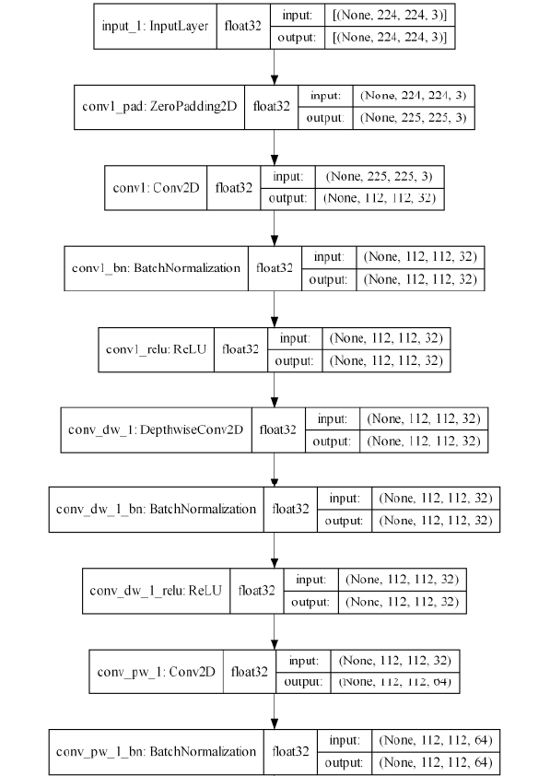

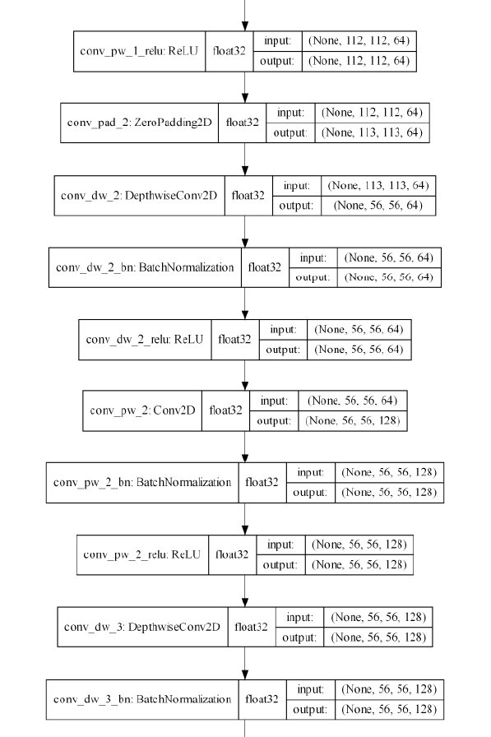

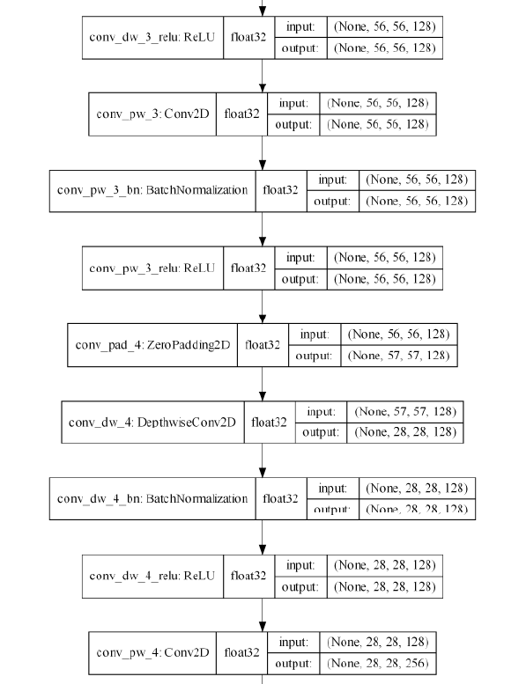

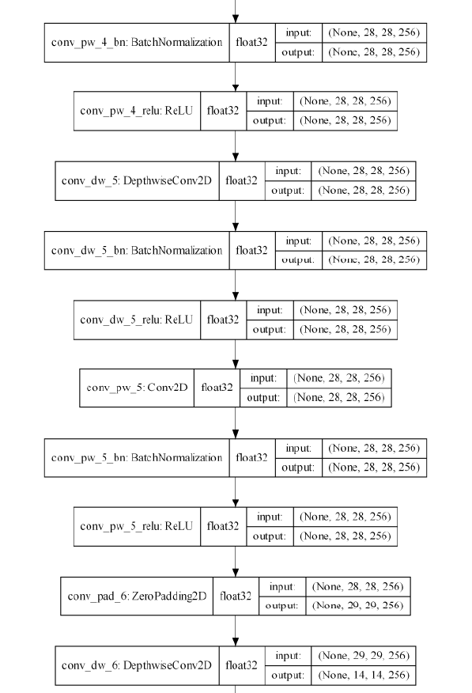

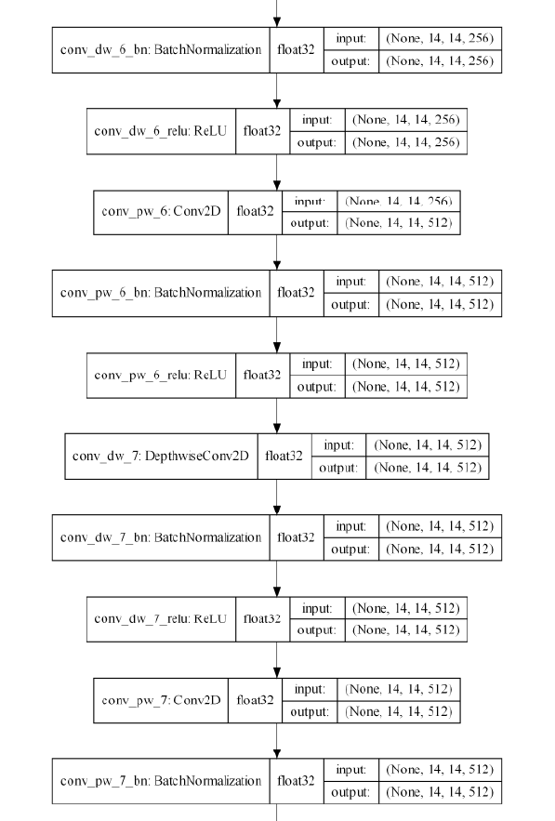

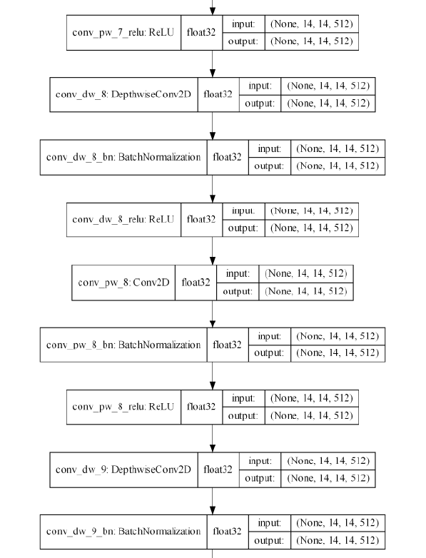

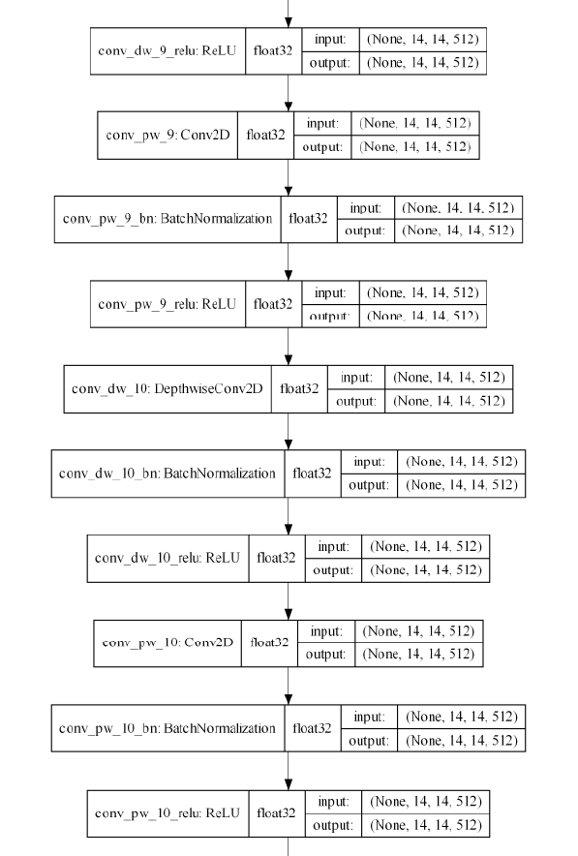

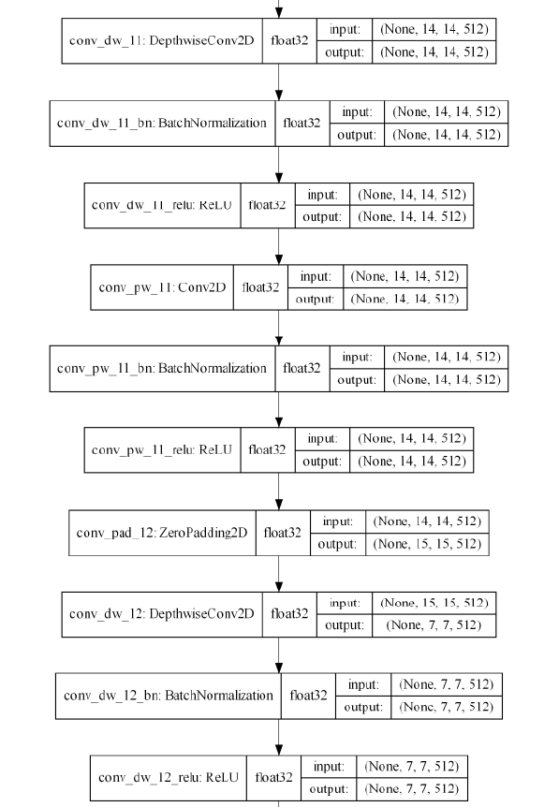

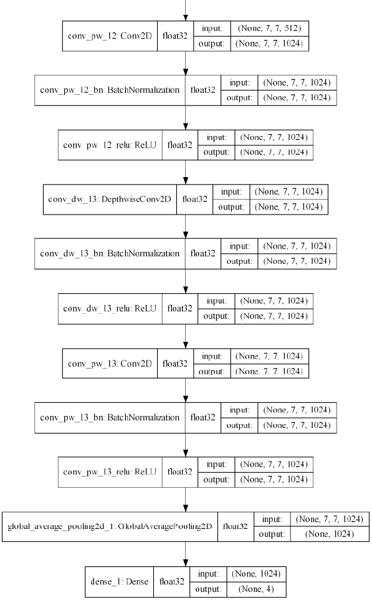

# Appendix 2: Machine Learning Service Code

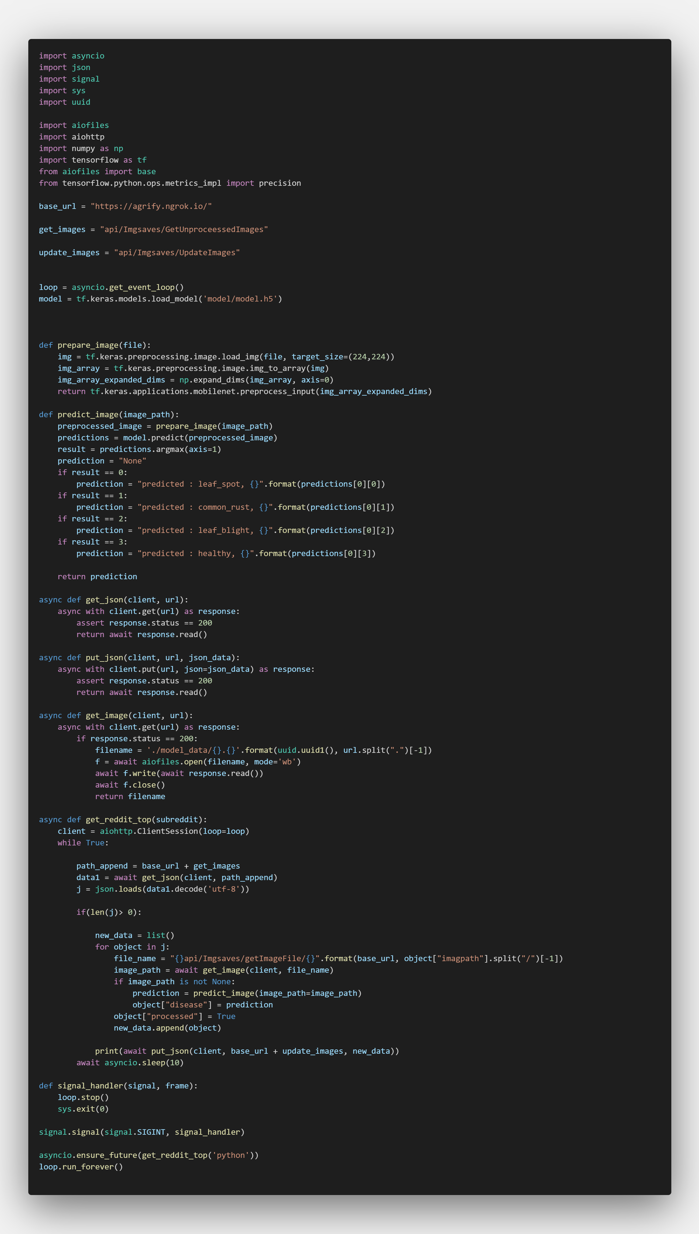

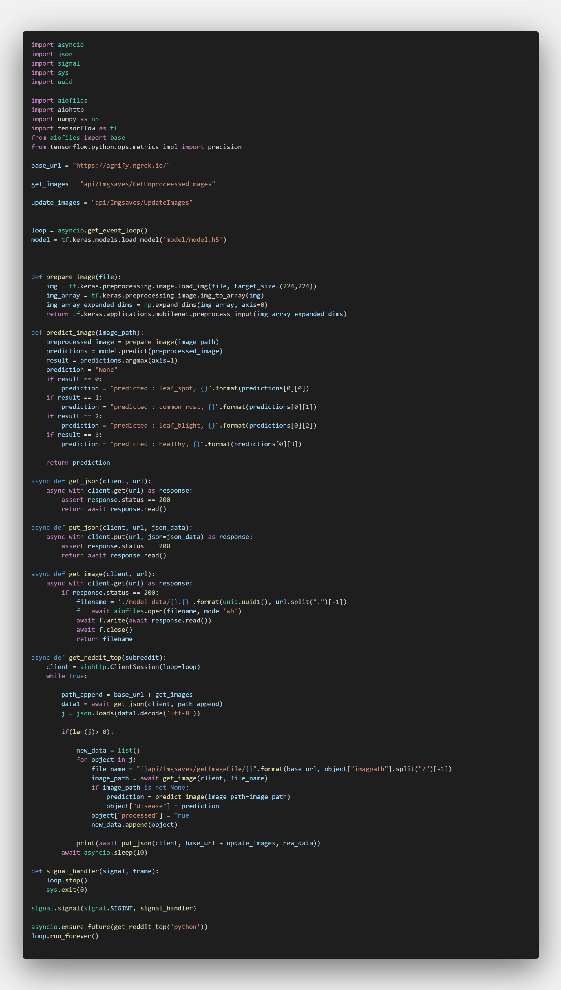

# Appendix 3: The Imgsave Controller Code (API)

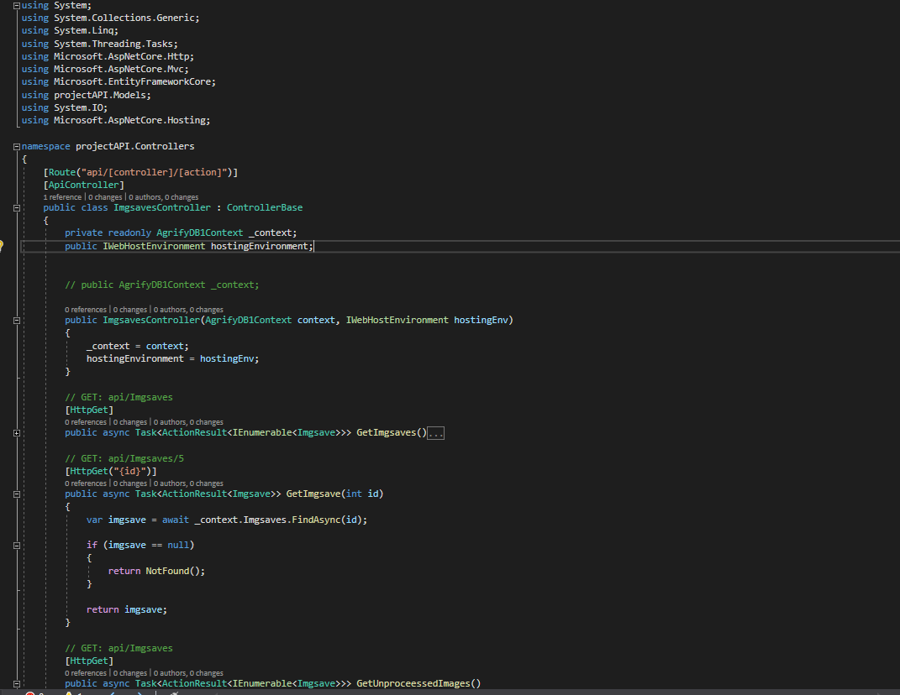

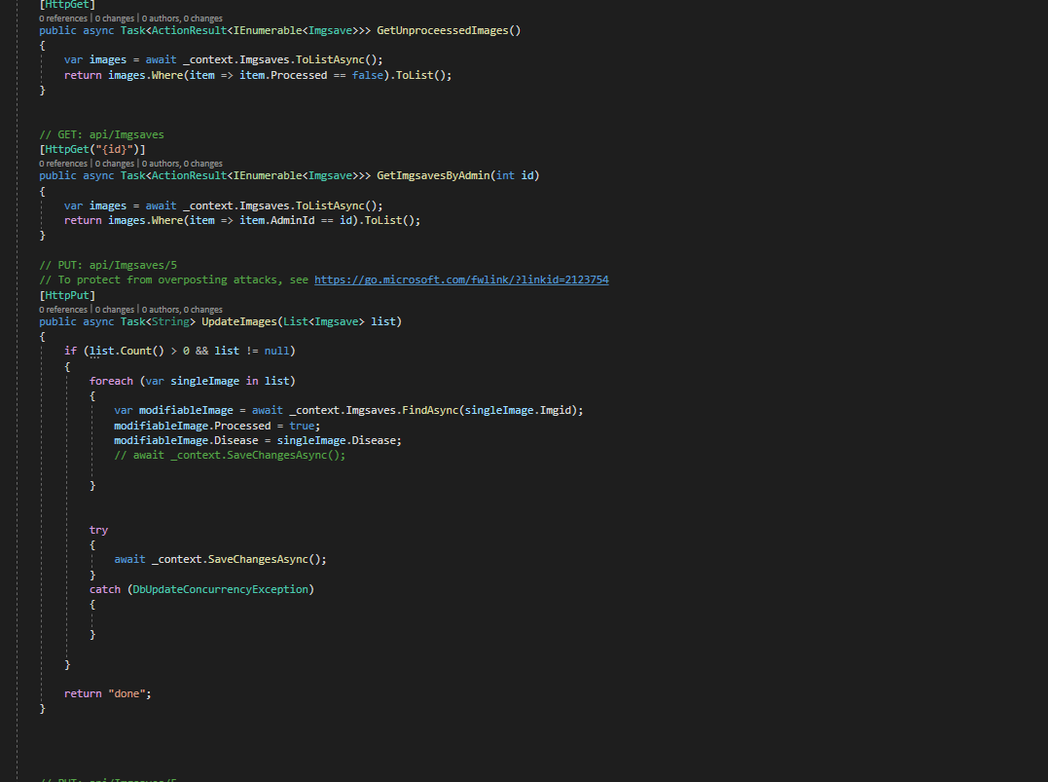

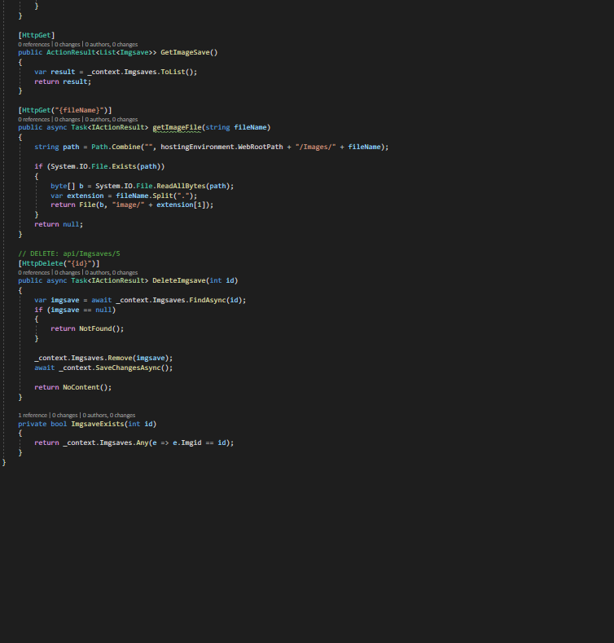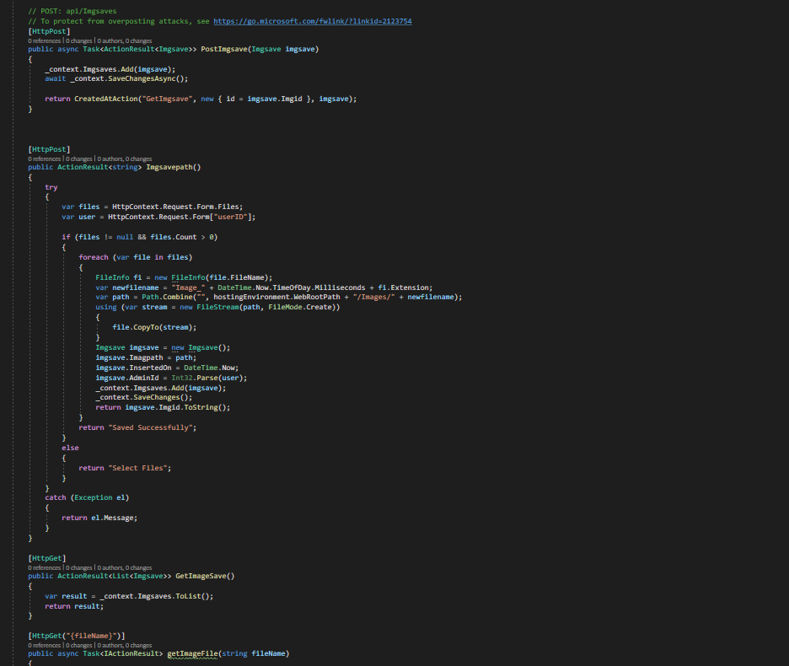

# Appendix 4: Imgsave model code (API)

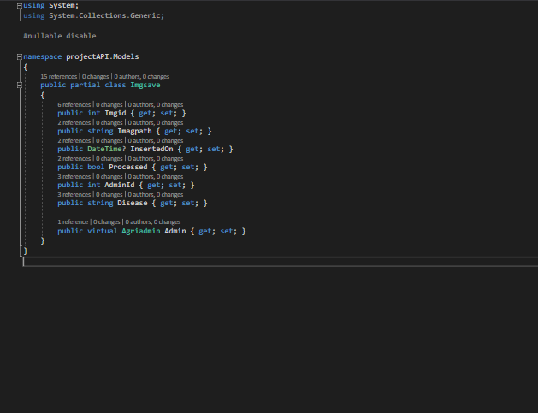

# Appendix 5: Agriadmin Code (API)

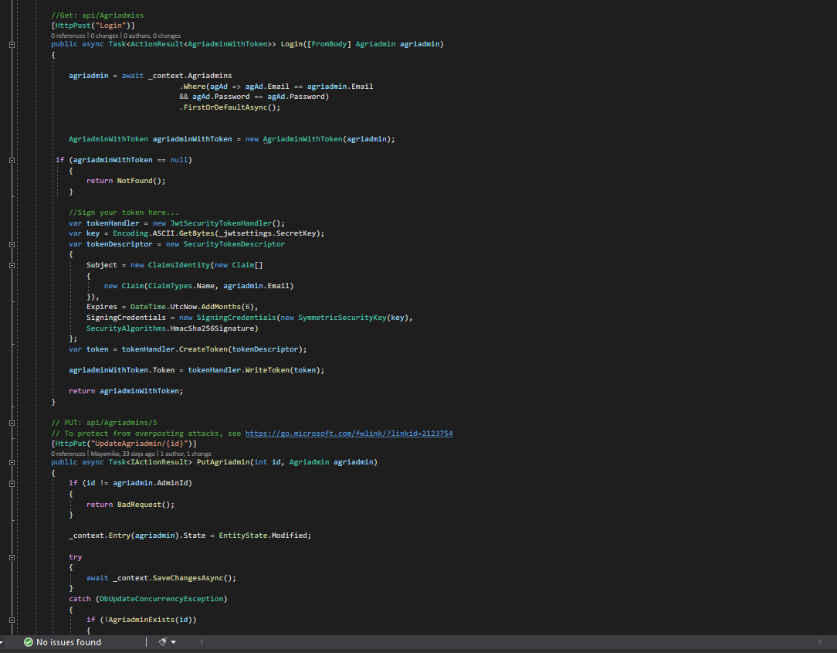

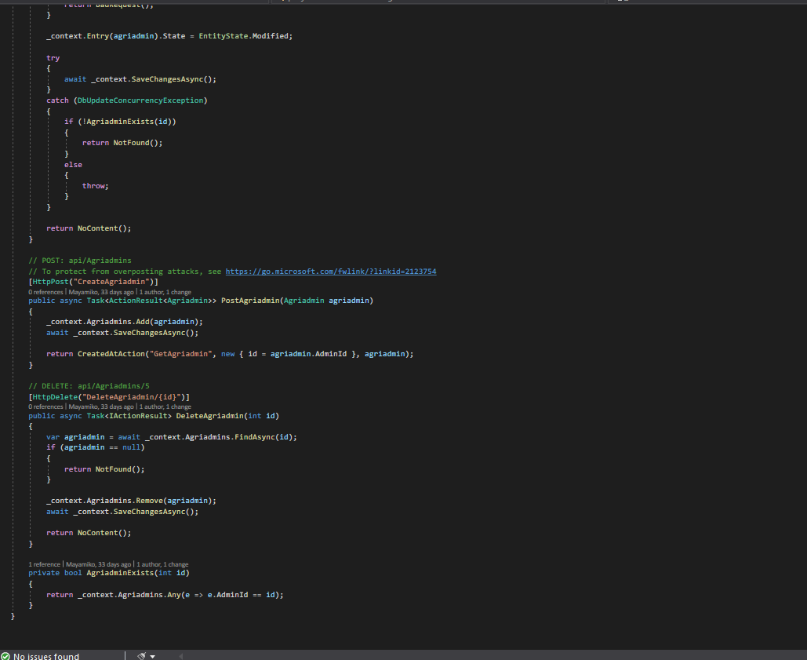

# Appendix 6: Agriadmin Model (API)

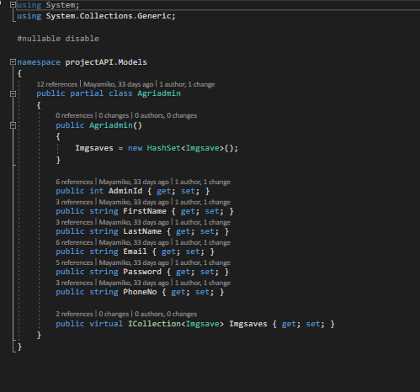

1. (Anon., n.d.)
2. (Anon., 2021)
3. What is ECDSA Encryption? How does it work? | https://www.encryptionconsulting.com/what-is-ecdsa/